MOBILE APPLICATION DEVELOPMENT PROJECT REPORT
STUDENT PORTAL MOBILE APPLICATION
Name: ILLICKWEL MUNYESI BENEDICTAS
Registration Number: BIT/2024/74342
Unit Code: BIT 4107
Course Title: Mobile Application Development
Lecturer: NYORO MICHAEL
Institution: MOUNT KENYA UNIVERSITY
Date of Submission: 09/06/2026

1.0 INTRODUCTION
This project focuses on the design and development of a Student Portal Mobile Application using modern Android development tools. The application is designed to simulate a real-world student management system where users can register, log in, view dashboards, check profiles, and access academic results.
The purpose of this project is to apply practical mobile development skills gained during coursework, including UI/UX design, Android programming using Kotlin, and application deployment using Android Studio.
The system demonstrates how modern mobile applications are structured using activities, XML layouts, and navigation between screens.
2.0 PROBLEM STATEMENT
Many educational institutions still rely on manual systems for managing student data, including registration, results viewing, and profile management.
These systems are slow, inefficient, prone to human error, and difficult to access remotely.
This project solves this problem by developing a digital mobile-based solution that allows students to access their information easily through a smartphone application.
3.0 PROJECT OBJECTIVES
The main objectives of this project include:
- To design a user-friendly mobile application interface
- To implement login and registration functionality
- To allow navigation between multiple screens
- To display student profile information
- To display academic results
- To design and implement a splash screen
- To apply modern Android development practices
4.0 TOOLS AND TECHNOLOGIES USED
4.1 Development Tools
- Android Studio (Primary IDE)
- Kotlin Programming Language
- XML for UI Design
- Android Emulator for testing
4.2 Design Tools
- Figma (Used for UI/UX wireframing and prototyping)
4.3 Version Control
- GitHub (for project backup and version tracking)
5.0 SYSTEM DESIGN
5.1 UI/UX DESIGN (FIGMA)
The system UI was first designed using Figma, which allowed visualization of login screen layout, registration screen, dashboard design, profile screen, and results screen.
[Insert Screenshot: Figma wireframes here]
5.2 APPLICATION ARCHITECTURE
The application follows a multi-activity architecture consisting of:
- SplashActivity (Startup screen)
- MainActivity (Login screen)
- RegisterActivity (User registration)
- DashboardActivity (Main navigation screen)
- ProfileActivity (Student details)
- ResultsActivity (Academic results)
6.0 SYSTEM IMPLEMENTATION
6.1 DEVELOPMENT APPROACH
The system was implemented using Android Studio with Kotlin programming language. Each screen was created using XML layout files and connected using Kotlin Activities.
6.2 MAIN FEATURES IMPLEMENTED
Splash Screen
Displays application name on launch and automatically navigates to the login screen after a short delay.
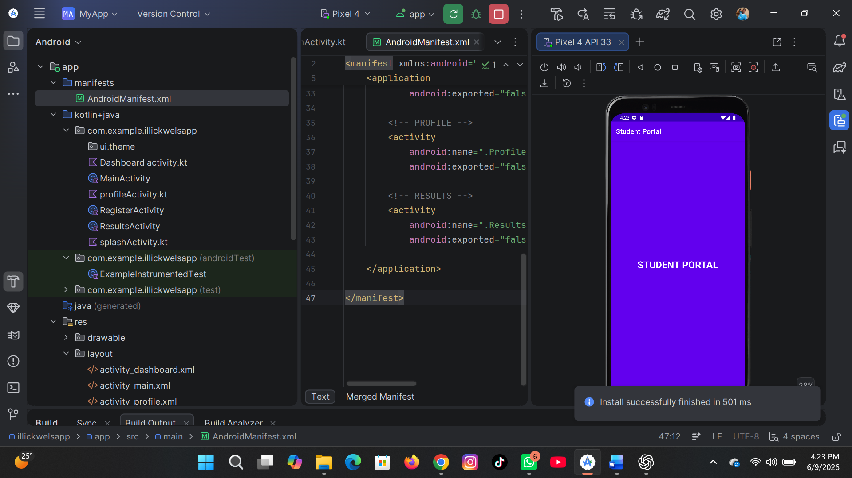
Login System
Allows users to input username and password, validates inputs, and redirects to the dashboard upon successful login.
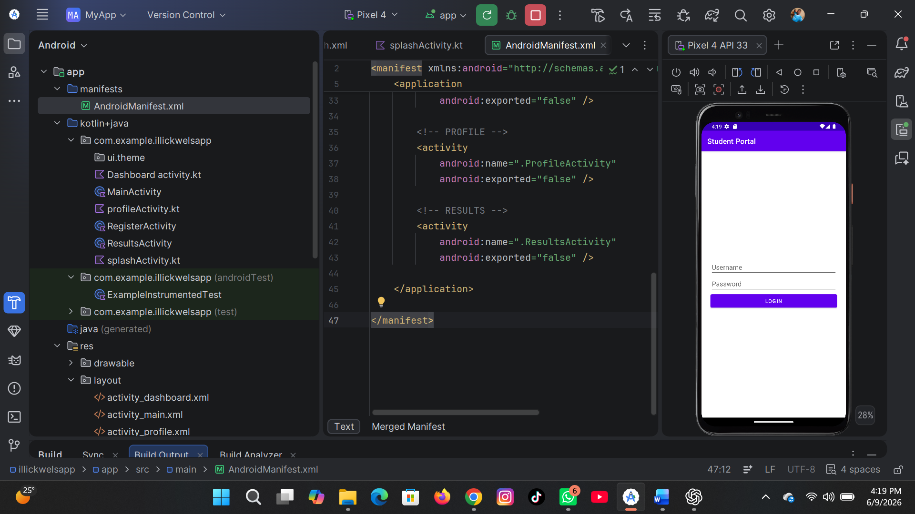
Registration System
Allows new users to register by entering required details and accessing the system.
Dashboard System
Acts as the main interface containing navigation options such as Profile, Results, and Logout.
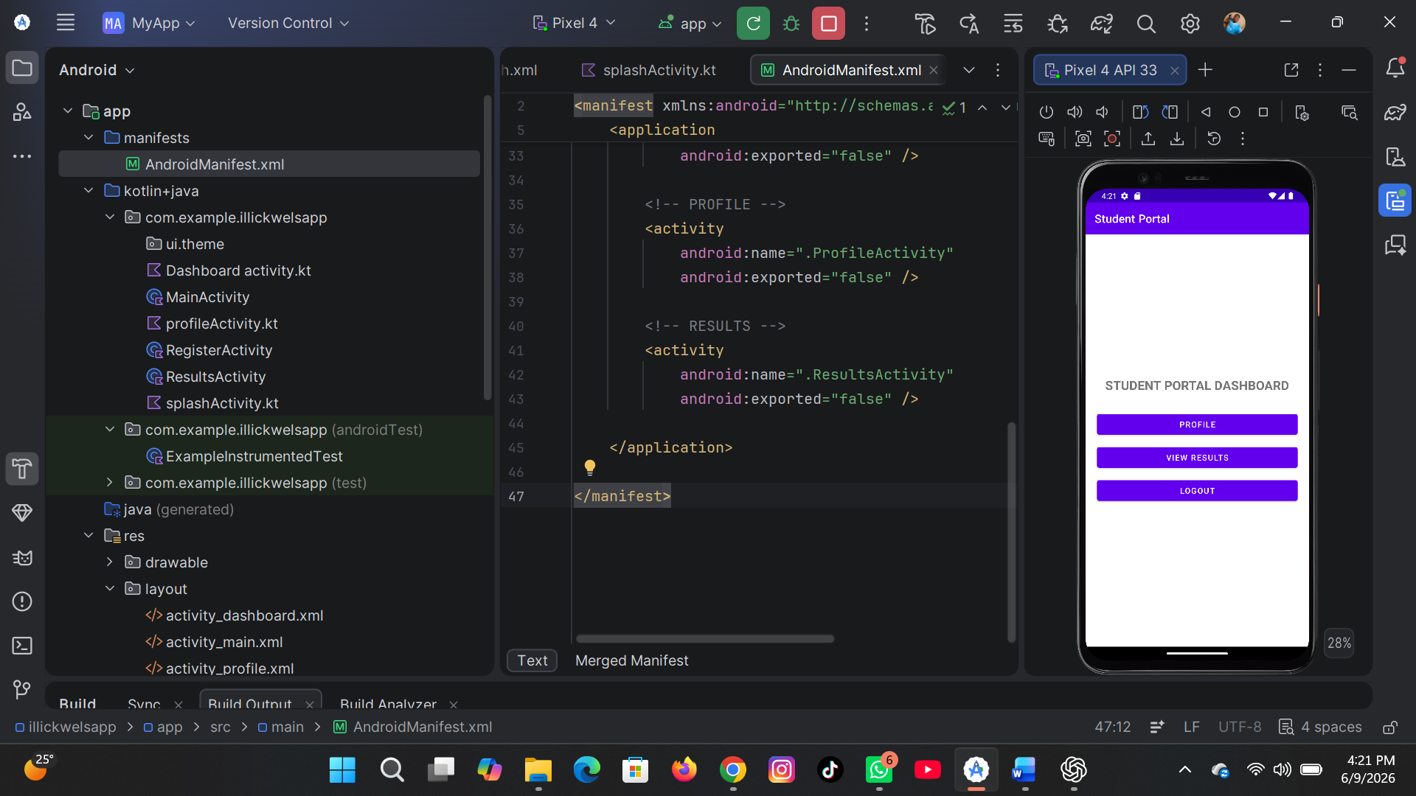
Profile Screen
Displays student details such as name, registration number, and course information.

Results Screen
Displays academic performance including subjects and grades.
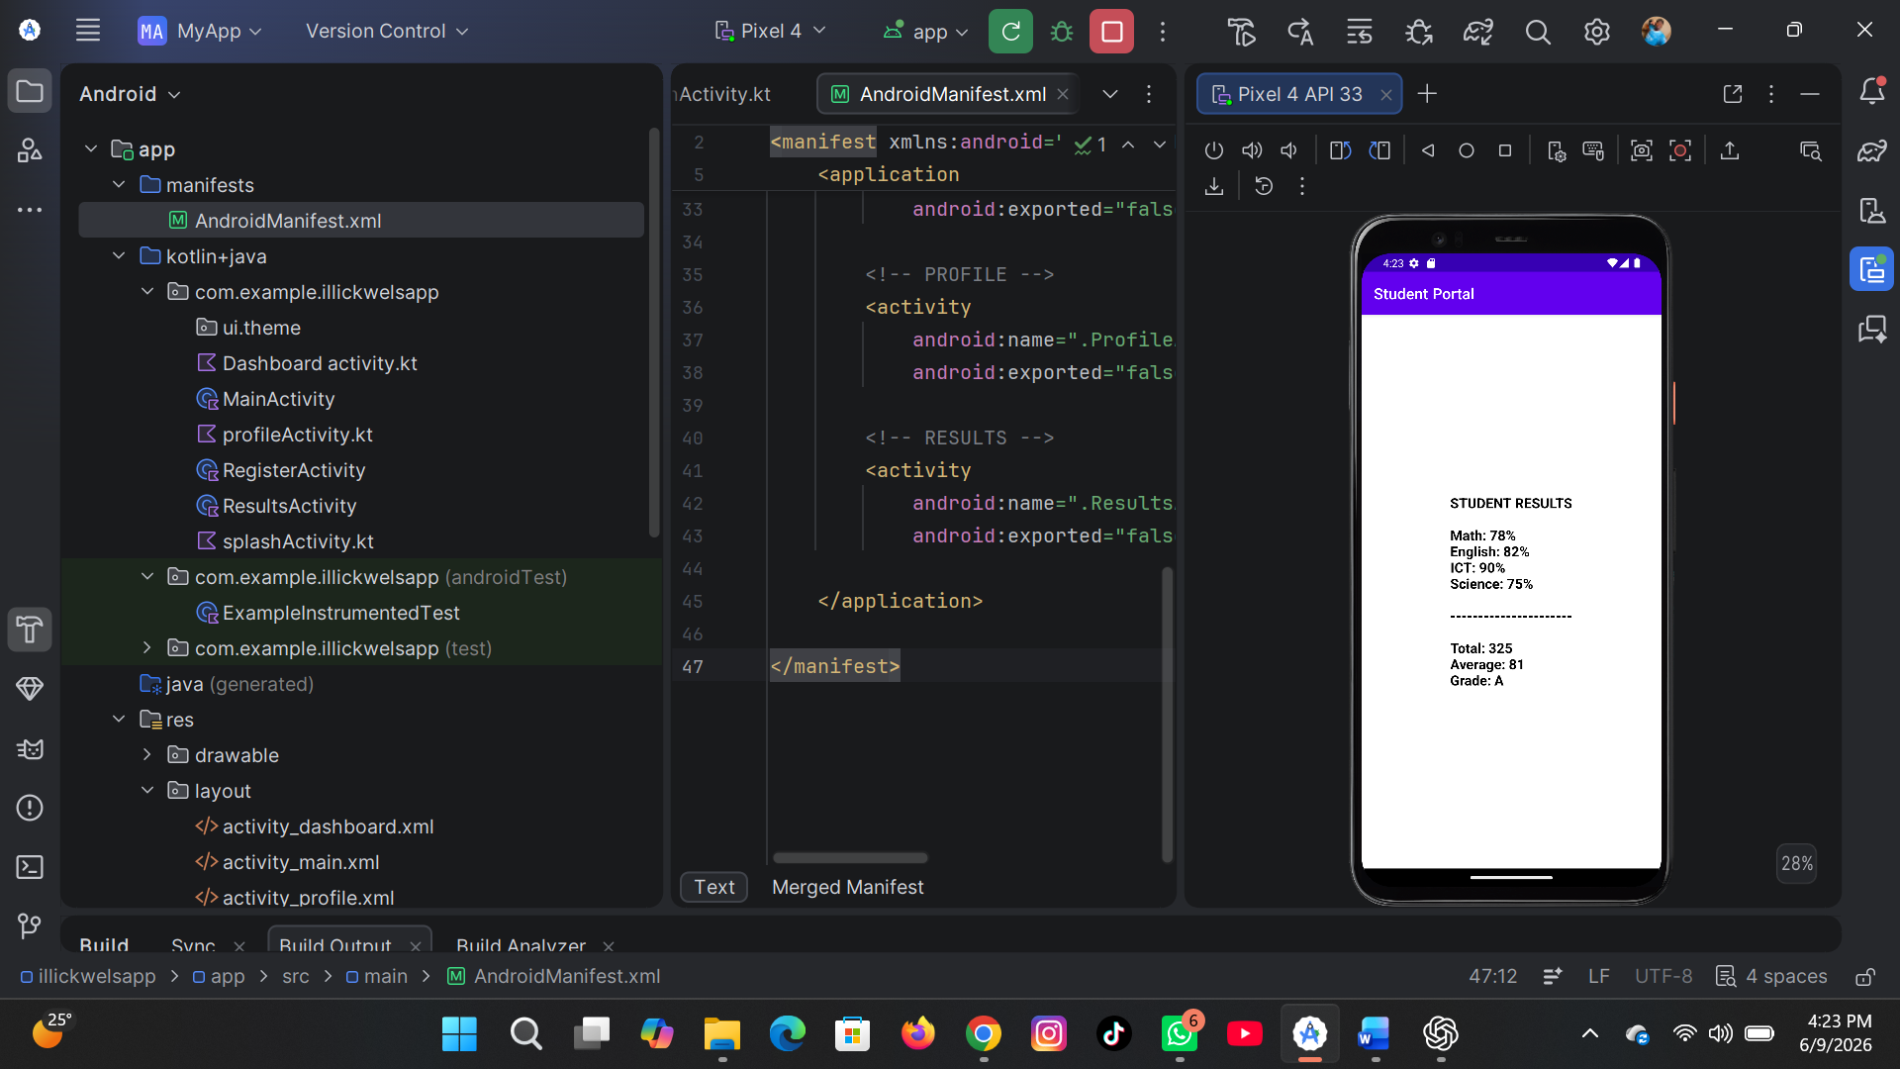
7.0 DATABASE / STORAGE APPROACH
This project uses a basic local data handling approach where information is passed between screens.
Future improvements may include Firebase database, SQLite, or cloud-based storage solutions.
8.0 TESTING AND RESULTS
The application was tested using the Android Emulator.
Test cases included login validation, navigation between screens, splash screen timing, and button functionality.
All features worked successfully without system crashes.
[Insert Screenshot: Running App on Emulator]
9.0 CHALLENGES FACED
- Gradle build errors during project setup
- AndroidManifest configuration issues
- Unresolved references in Kotlin files
- Missing or incorrect XML layout files
10.0 SOLUTIONS IMPLEMENTED
- Corrected AndroidManifest.xml settings
- Fixed Gradle dependencies
- Ensured correct linking between Kotlin and XML files
- Created all required layout files properly
11.0 FIGMA UI DESIGN
Figma was used to design and plan the user interface before implementation. It helped in creating a clear layout structure, improving design consistency, and ensuring a better user experience.
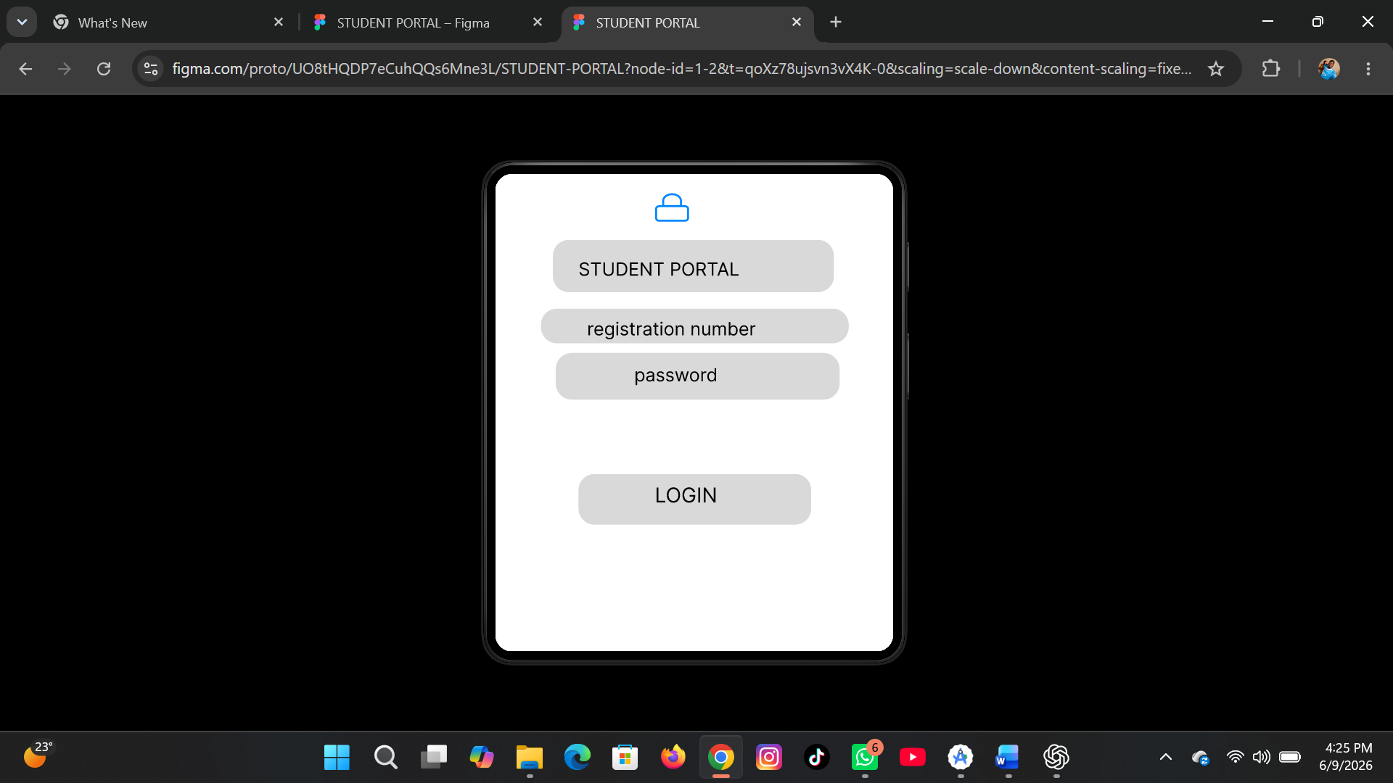

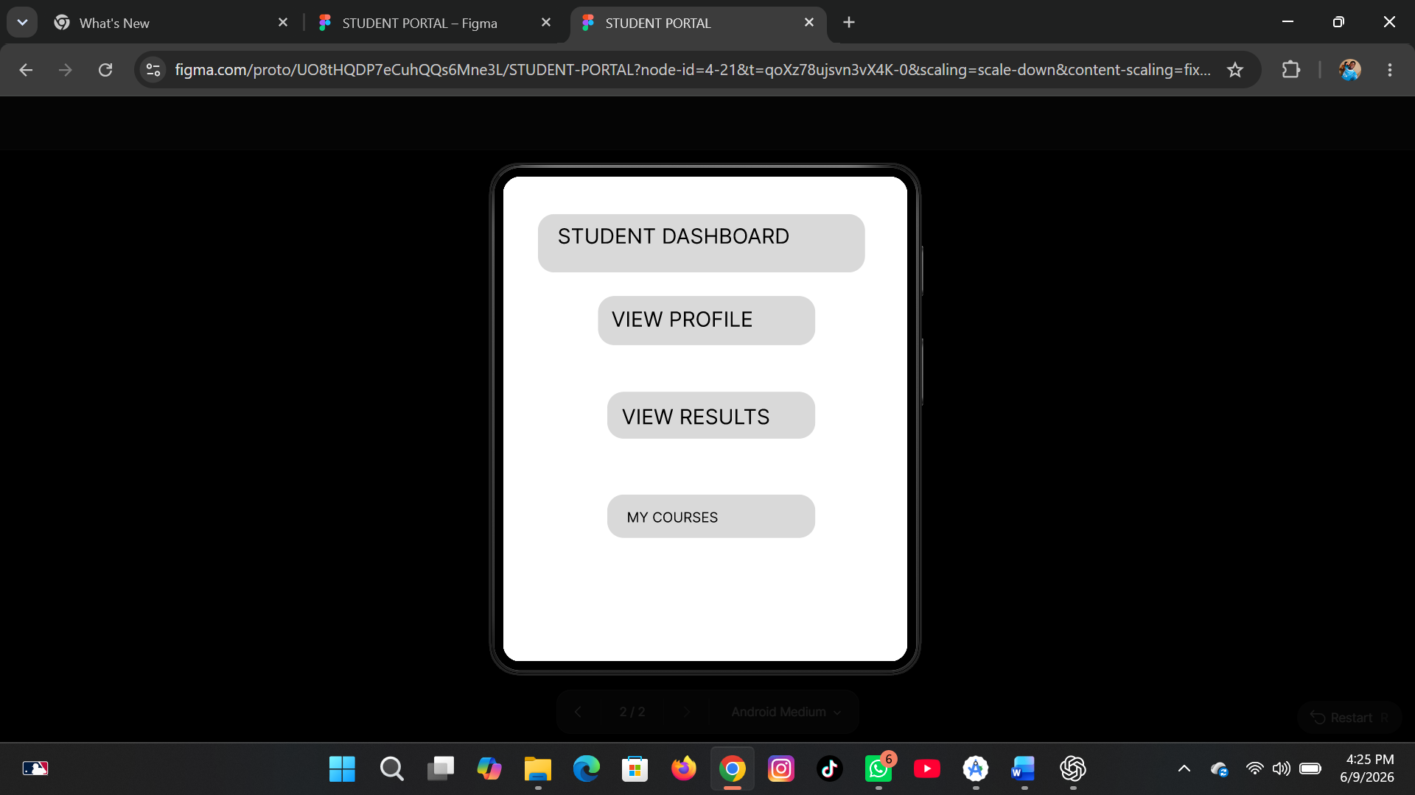
12.0 SYSTEM LIMITATIONS
- No real database integration
- No backend authentication system
- Static data used in some sections
13.0 FUTURE IMPROVEMENTS
- Integration with Firebase authentication
- Real-time database connectivity
- API integration
- Enhanced UI animations
- Role-based user access
14.0 CONCLUSION
The Student Portal Mobile Application was successfully developed using Android Studio and Kotlin. The project demonstrates essential mobile development skills such as UI design, navigation, and system structuring.
It provides a strong foundation for building more advanced real-world applications.
15.0 REFERENCES
Android Developer Documentation
https://developer.android.com
Kotlin Documentation
https://kotlinlang.org
Figma Design Tool
https://figma.com
Android Studio
https://developer.android.com/studio

